Renfrewshire Employability Provision Fact Sheet
This factsheet is intended for use by those referring individuals for employability support in Renfrewshire. Similar information, designed for public use will also be available via the Opportunities Portal accessed via the Invest website and YPG Renfrewshire websites. This fact sheet is produced by the organisation delivering this particular offer of support or training and any queries should be directed via the contact details provided.
Provider | BDA Ltd
Name of Project/Programme/Support | Self-Employment.  Support to set up and run your own business.
Referral Process | Please contact –  Barbara Mennie  07771 756871  barbara@bdalimited.co.uk
Who is this programme for? | The programme is aimed at helping anyone thinking of setting up in self-employment.  Age ranges – anyone. Not age restricted.  Priority groups -  • Jobless care experienced young people (16- 26?).  • 16-19 year olds/school leavers without a positive destination  • Those involved in the criminal justice system (all age).  • Unemployed people with physical or learning disability able and wishing to progress/return to work (all age) .  • Low income employed parents with physical or learning disability or with children with a physical or learning difficulty (all age).  • Unemployed people with health conditions wishing to progress/return to work including those in recovery from addictions (all age).  • Long term unemployed residents (all age).  • Unemployed residents residing in 5% most deprived data zones (SIMD2020) (all age)  • Unemployed Black and minority ethnic residents including refugees (all age).  • Unemployed people in homeless /temporary accommodation (all age)  • Unemployed/low income parents (all age).
Referral criteria | Any person who is in any of the priority groups/unemployed.
Start date | This is a rolling programme from 01 April 22 to 31 March 23
End date | As above
Number of places in each course | 25 spaces
Employability Pipeline stages | 5
What is the aim of the project/programme/support? | The aim of the programme is to enable participants to establish their self-employment businesses and give them an opportunity to test trade. The training concentrates on the skills necessary to start and run a new business; it applies to anyone considering self-employment irrespective of the nature of the business.
Summary of content | The support will last 42 weeks and will be in 2 stages:  Stage 1: Getting Started- 16 weeks  Participants will be given 16-weeks of intensive one-to-one training support from an experienced business trainer, to enable them to establish their self-employment business and give them an opportunity to ‘test trade’.  One-to-one support will be provided for at least one hour per week and tailored to suit the participant. Initially, face to face meetings will be required, but as the trainer and participant get to know each other, and as self-employment training progresses successfully, these meetings may take the form of phone calls or cloud-based video conferencing using Zoom or GoToMeeting.  During Stage 1, a participant will be helped to register their business, open a business bank account, obtain relevant licences and insurances, complete a Business Plan and undertake any specific skills training, such as accounting and record keeping, marketing, e-business, social networking for business etc. Any grant and/or loan funding applications will be completed, as will signposting to any relevant partner agencies for free, specific support.  In addition to the one-to-one training support, the participant will be expected to attend a range of business skills training sessions,(face-to-face or webinars) each lasting around 90 minutes. These sessions will be group sessions, and cover the skills necessary to start and run a new business – Facebook for business, Instagram for business, book keeping, selling skills, e-commerce, employing people etc.  A Business Support Grant up to a maximum value of £250 will be available. This could be used by participants to purchase any tools, equipment or marketing materials to assist them in the start-up of their business. Quotes for the proposed spend of the grant must be submitted in advance of purchase and subsequently supported by a receipt or invoice.  Stage 2: Mentoring & Support – 26 weeks  Stage 2 will be a mentoring and support programme, facilitating participants in achieving sustained self-employment. It is our aim that participants remain in self-employment for at least 26 weeks after their initial 16 weeks of one-to-one support.  Mentoring meetings will be arranged every 2 to 4 weeks, dependant on the needs of the participant. The BDA trainer will utilise these meetings to offer further support, particularly with HMRC compliance, record-keeping; registering for Class 2 National Insurance and preparing for Self-Assessment.
Certification
Name/Code (if appropriate) of Unit/Module/SCQF rated qualification (where the qualification is not SCQF credit rated please include a brief description) – add more rows as required | SCQF Level | SCQF credit points
Not applicable

Project/programme outcomes | The participant outcome will be self-employment.  Self-employment enables a participant to be in charge of decision-making, allowing a freedom to explore creative solutions to problems and having the satisfaction of seeing a business idea through to completion. Participants will be to set their own working hours and fit their self-employment work around caring and family commitments, often leading to an improved quality of life.
Participant Travel, Allowances, tools, uniforms etc | A Travel Allowance covering the cost of a daily bus pass will be paid.  A Business Support Grant up to a maximum value of £250 will be available. This could be used by participants to purchase any tools, equipment or marketing materials to assist them in the start-up of their business. Quotes for the proposed spend of the grant must be submitted in advance of purchase and subsequently supported by a receipt or invoice.
Additional information
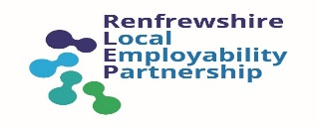
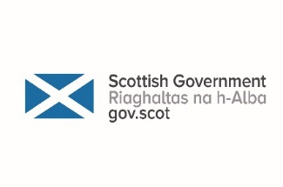
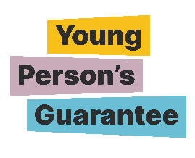
This project has been supported by the Renfrewshire Employability Grants Programme
Funded by:
Managed by:

